A national survey investigating the impact of the COVID-19 pandemic on core and higher breast radiology training in the UK

Sarah Carpenterª, Yitka Graham^{b}, Trupti Kulkarni^{c}, Iain Lyburn^{d,e,f}, Sarah Vinnicombe^{d}, Sheetal Sharma^{g}, Nisha Sharma^{h}, Simon Lowes^{a,i,*}
ª Breast Screening and Assessment Unit, Queen Elizabeth Hospital, Gateshead, NE9 6SX
^{b} Helen McArdle Nursing and Care Research Institute, Faculty of Health Sciences and Wellbeing, University of Sunderland, SR1 3SD
^{c} Nightingale Centre & Genesis Prevention Centre, University Hospital of South Manchester, M23 9LT
^{d} Gloucestershire Hospitals NHS Foundation Trust, Cheltenham, GL53 7AN, UK
^{e} Cobalt Medical Charity, Linton House, Thirlestaine Rd, Cheltenham, GL53 7AS, UK
^{f} Cranfield University, College Rd, Cranfield, Wharley End, Bedford, MK43 0AL
^{g} Liverpool University Hospitals NHS Foundation Trust, Prescot St, Liverpool, L7 8XP
^{h} Breast Unit, St James’s University Hospital, Leeds, LS9 7TF
^{i} Translational and Clinical Research Institute, Newcastle University, Newcastle upon Tyne, NE2 4HH

*Corresponding author.
E-mail address: simon.lowes@nhs.net (S. Lowes)

Acknowledgements
The authors would like to thank the British Society of Radiology Executive Committee for supporting the study, as well as the specialty trainees and consultants who completed the survey.

Ethical approval
Ethical approval was gained from the University of Sunderland Research Ethics Group. Informed consent not required.
Keywords: Breast Radiology, Specialty Training, COVID-19, Clinical Radiology Workforce
Abstract
AIM: To investigate the impact of the COVID-19 pandemic on core and higher breast radiology training in the UK from the perspective of trainees and new consultants.
MATERIALS AND METHODS: A survey comprising 24 questions was distributed to UK radiology trainees via the regional Junior Radiologists Forum representatives under the auspices of the British Society of Breast Radiology (BSBR).
RESULTS: 69 eligible responses were received representing all UK training regions. 55 % of respondents completing either a core or higher breast rotation felt that the pandemic had a negative effect on their breast training. There was an overall reduction in exposure to the key breast imaging modalities when rotations took place during the pandemic. Completing a core breast rotation during the pandemic was less likely to attract trainees to higher breast training. 3 of 4 breast radiology consultants in their first year post-CCT felt the pandemic reduced their preparedness for becoming consultants. Positive outcomes included the increased use of online educational resources and remote multidisciplinary meetings.
CONCLUSIONS: As well as having a negative impact on breast radiology training overall, the pandemic has had a detrimental effect on attracting trainees to breast radiology as a future career. It is of key importance that trainees have a positive core breast rotation since this experience appears central to many trainees’ decisions to pursue higher breast training. Increased use of online learning resources has also been positively received and is a valuable approach to learning that can be maintained in the longer term.

Introduction
The disruption of clinical services resulting from the COVID-19 pandemic has been significant and widespread. Redistribution of resources to focus on the treatment of COVID-19 patients while maintaining existing already-stretched essential acute services for non-COVID-19 patients has exerted a huge strain on healthcare systems worldwide.¹ As a consequence of prioritising resources towards frontline acute care, many clinical and ancillary services deemed non-essential have been suspended, including elective procedures, outpatient clinics, non-COVID-19 clinical research, and the teaching and training of healthcare professionals. A survey by the General Medical Council has found that postgraduate medical training across all specialties has been disrupted by the pandemic, including clinical radiology, with 61 % of radiology trainees reporting a lighter workload.² A significant reduction in workload was also reported in another survey of radiology trainees within a single deanery.³
In addition, the FRCR (Fellowship of the Royal College of Radiologists) postgraduate examinations were suspended, and a survey of the Royal College of Radiologists’ (RCR) Junior Radiologists Forum (JRF) found a reported decrease in the amount of local and regional teaching for radiology trainees across the United Kingdom, as well as a decrease in the quality of local training.⁴ Furthermore, trainees from 76 % of training programmes were redeployed to hospital wards at some point.⁴ In order to help mitigate the decrease in local and regional teaching, there was a reported increase in the level of national teaching, for example via RCR webinars, which have been well-received.⁴
While the impact on radiology training has been an unavoidable consequence of the COVID-19 crisis, its consequences could be long-lasting; the clinical radiology workforce as a whole is already deplete, so maintaining training is critical to ensure the uninterrupted support and development of our imaging services. In particular, ensuring there are no deficiencies in the training of radiologists is of the utmost importance given the huge pressures on imaging services and the chronic shortfall of clinical radiologists nationwide.⁵ Breast radiology notably suffers from a chronic workforce crisis that shows no imminent signs of improving.⁵ Although there is evidence that clinical radiology training in general has been negatively impacted by the pandemic, and there has been an overall reduction in subspecialty radiology training,³ the effect on training in individual specialist interest areas has not yet been investigated.
The aim of this study was to investigate the impact of the COVID-19 pandemic on core and higher breast radiology training in the UK from the perspective of trainees and new consultants. Experiences of those who completed their rotations before the pandemic were compared with those who completed it during the pandemic. As well as investigating how training itself was impacted, we asked how this affected the likelihood that core trainees might pursue higher training, as well as asking higher trainees in breast radiology and new consultant breast radiologists how this has affected their preparedness for becoming a consultant.

Methods
A survey comprising 24 questions was designed by the authors to investigate the impact of COVID-19 on core and higher breast radiology training in the UK (Appendix 1). The survey was compiled online through SurveyMonkey® and distributed to UK radiology trainees via the regional Junior Radiologists Forum representatives under the auspices of the British Society of Breast Radiology (BSBR).
The survey was opened in May 2021 and remained active for 8 weeks. Participation in the survey was incentivised by offering 3 prizes of Amazon vouchers (£100, £50 and £25). Winners were drawn at random.
Ethical approval was gained from the University of Sunderland Research Ethics Group.

Results
Response rate
A total of 75 responses were received. Six of these were excluded either because of incomplete responses or the respondent did not meet the required criteria (post CCT in non-breast subspecialty), leaving 69 for subsequent analysis.
Of these, 65 were received from current radiology trainees, and 4 were received from UK based breast radiologists who completed their specialty training in the past year (i.e. having spent some time in training during the pandemic); overall, core trainees and higher trainees, either in specialist breast training or another specialist area, were well represented as a proportion of all respondents (Fig 1), with 48 % of respondents in core training (33/69), 46 % in higher training (32/69; 13 in breast higher training and 19 in another specialist interest area), and 6 % breast radiology consultants in their first year post CCT (certificate of completion of training; 4/69). There was at least one respondent from each training region (Table 1); note that the London training schemes were grouped together as one, as were the Scottish schemes.
Impact of COVID-19 on training experience and workload
Overall, 26 % of respondents (18/69) were redeployed to other hospital departments at some point during the pandemic (data not shown); 78 % of those redeployed (14/18) were core trainees, with the remainder higher trainees (4/18). The core trainees who were redeployed represented 42 % of all core trainee respondents (14/33). None of the breast radiology consultants in their first year post CCT were redeployed as trainees. Overall at least one respondent was redeployed from 6 of the 16 regions (38 %). One respondent used a free text box of a different survey question to make the comment that although they were not redeployed, they were put on a “Covid radiology rota”, which meant they “were doing only acute CTs and hot reports for Covid chest x-rays and doing long shifts of 12 hours with consecutive 3 days on alternating between nights and days with days off in between.” [Wording amended slightly to aid flow, but content unchanged].
Eighty-six per cent of respondents (59/69) reported having completed a core breast rotation at some point before or during the pandemic; 36 % (25/69) completed a core rotation before the pandemic, and 49 % (34/69) completed one during the pandemic (data not shown).
Reflecting the fact that some core trainees would have made the transition from core to higher training during the pandemic, and that some of the higher breast trainees would have made the transition to becoming a consultant, 13 % of respondents (9/69) reporting being in higher breast training at some point before the beginning of the pandemic, with 22 % of respondents (15/69) in higher breast training at some point during the pandemic.
To ascertain basic background information about training environments, all respondents were asked how many trainees typically work in their local breast unit in each rotation. Regarding core trainees, of the 69 respondents, 3 (4 %) stated there were typically no core trainees, 55 (80 %) said there were 1-2, 3 (4%) said there were 3-4, and 8 (12 %) said they were unsure. Regarding higher trainees, of the 69 respondents, 14 (20 %) stated there were typically none, 38 (55 %) said there were 1-2, 2 (3 %) said there were 3-4, and 15 (22 %) said they were unsure.
Before being asked in detail about the effects of the pandemic on their core or higher training experience, respondents were asked about the overall impact of the pandemic on their breast training as a whole, whatever their stage (Fig 2). Excluding 11 participants who selected “Not Applicable (I was not scheduled to be on a breast rotation at any point during the COVID-19 pandemic)”, 55 % of respondents (32/58) felt that the pandemic had a negative effect on their breast training, and 45 % (26/58) felt it had no impact. No respondents felt it had a positive impact.
Respondents who had completed a core or higher breast rotation at any point were asked to rate their experiences of exposure to four key breast imaging modalities during their placements: mammography, ultrasound, MRI, and image-guided breast procedures. The results are separated according to whether the rotation was at core (Fig 3) or higher level (Fig 4) and whether trainees completed their rotations before (Figs 3A and 4A) or during the pandemic (Figs 3B and 4B). For respondents completing core rotations during the pandemic, a greater proportion felt that their exposure to mammography, ultrasound, and image-guided breast procedures, was less than or significantly less than expected compared to when core rotations were completed before the pandemic (Fig 3). Overall a greater proportion of trainees reported their exposure to breast MRI was less than or significantly less than expected when compared to the other modalities, and this did not seem to change whether the rotation was done before or during the pandemic (Fig 3). For those doing higher breast training, a greater proportion of respondents doing their rotations during the pandemic felt that exposure to all four modalities was less or significantly less than expected compared to when rotations were done before the pandemic (Fig 4).
Of the 15 respondents who were on a higher breast rotation during the pandemic, 27 % (4/15) felt their workload was unchanged compared to before the pandemic, 27 % felt their workload decreased and a further 27 % felt it significantly decreased (Fig 5). Two respondents (13 %) reported their workload increased, while none reported it has significantly increased. One respondent selected Not Applicable.
Of all respondents who were on either a core or higher breast rotation during the pandemic, 47 % (21/45) reported that breast multidisciplinary team (MDT) meetings continued as normal throughout the pandemic, 11 % reported face-to-face meetings continued but were less frequent, 31 % reported that face-to-face meetings stopped altogether, and 11 % were unsure (Fig 6A). Eighty-two per cent (37/45) reported that there were opportunities for remote access to the MDT meetings, 4 % reported there were no remote access opportunities, and 13 % were unsure (Fig 6B). Of the same respondents completing either a core or higher breast rotation during the pandemic, 47 % (21/45) reported that alternative non-face-to-face teaching methods were in place, such as Microsoft Teams, Star Leaf, or Zoom. Twenty-four per cent (11/45) reported there were no alternative teaching methods, 4 % (2/45) were unsure, and 24 % (11/45) gave no response (Fig 6C).
Impact on likelihood of pursuing a career in breast radiology
Core trainees were asked if their rotation before or during the pandemic impacted their decision to pursue a career in breast radiology (Fig 7). Of the respondents who did their core rotation before the pandemic, 18 % went into their core rotation with a plan to pursue higher breast radiology, and their core rotation experience did not alter this decision; this proportion was similar for trainees completing their core rotation during the pandemic, increasing marginally to 21 %, suggesting that any difference in core training experience during the pandemic compared to before it did not greatly influence career choice on those already planning to pursue higher breast training. In contrast, whereas 41 % of respondents who did their core rotation before the pandemic felt their core rotation experience positively changed their decision to now want to pursue breast radiology, this figure was just 9 % in those who completed their core rotation during the pandemic, indicating that a significant opportunity to recruit trainees to breast radiology was lost because of the different experience of core breast training during the pandemic compared to before it. This is also reflected in the finding that the proportion of respondents who had no intention of pursuing a career in breast radiology prior to their core rotation, and whose core rotation experience did not affect this decision, increased from 27 to 41 % when their rotation took place during pandemic compared to before it, again suggesting that the core rotation experience has the potential to positively change trainees’ minds about breast radiology, even when they previously had no intention of pursuing it, and that trainees’ different experiences during the pandemic compared to before it, have to some extent negated this.
The proportion of trainees who wanted to pursue higher breast radiology training before their core rotation, but changed their mind against it based on their core training experience, was similar when the core rotation was completed before compared to during the pandemic, if anything showing a marginal increase from 9 to 12 %. Just 5 % of respondents who did their core breast rotation prior to the pandemic were undecided about their career choice upon completion of the rotation, compared to 18 % who did their rotation during the pandemic, again indicating the potential for a positive core training experience to cement trainees’ decisions (Fig 7).
Impact on preparedness for becoming a consultant breast radiologist
Of 13 respondents currently higher breast training, 6 respondents (46 %) feel they will be less prepared for becoming a consultant as a result of the COVID-19 pandemic, and 7 (54 %) feel they will be prepared despite the pandemic (Fig 8A). Of the 4 consultant breast radiologists in their first year post CCT, 3 respondents (75 %) felt they were less prepared for becoming a consultant as a result of the pandemic, and one (25 %) felt prepared despite the pandemic (Fig 8B).
Positive outcomes of COVID-19 pandemic on training and things that could have been done differently
In relation to breast radiology education, respondents were asked to provide details on any positive outcomes resulting from the pandemic. This is summarised in Table 2. Notably, though perhaps unsurprisingly, the most common themes centred around the increased use/availability of online resources such as webinars, online teaching/educational material, online/remote MDTs, and virtual conferences.
In terms of what was felt could have been done differently, there was again emphasis placed on the use of online/remote facilities, such as more webinars, live online teaching, educational resources, remote MDM opportunities, and better home reporting capabilities, as well as being allocated more time to access these (Table 3). There were acknowledgements of less hands-on and case-based clinical exposure, with comments around needing more MRI, missed opportunities for reporting mammograms because of suspension of the screening programme, and there were suggestions for better opportunities for simulated biopsy practice. One respondent commented they had not had a core breast rotation during ST1 or ST2 (though stated they felt this was not necessarily as a result of the pandemic), and felt this was a missed opportunity for learning, and that they felt disadvantaged as a result. They also felt uninformed regarding the possibility of pursuing breast radiology as a career choice because they have not had any clinical experience to help them make that decision. There were also 13 respondents who felt that nothing could be done differently, with six respondents providing supporting comments, two acknowledging that it would have been hard doing things differently given the situation, and the others providing positive comments on the experiences they did have.
Awareness of British Society of Breast Radiology and online learning resources
With the expectation of trainees having greater reliance on online learning resources during the pandemic, and the recognition that having an awareness of the British Society of Breast Radiology (BSBR) and its potential role in either providing, or directing trainees towards, appropriate online resources, may be important in supporting trainees’ learning, the participants were asked about their awareness of the BSBR and whether they had used the website to access any learning resources via the links provided.
Overall 49 % of all respondents (34/69) had heard of the BSBR prior to receiving their invitation to the survey. When broken down by training status, 39 % of core trainees (13/33), 92 % of higher breast trainees (12/13), 26 % of higher trainees in another specialty interest area (5/19), and 100 % of consultant breast radiologists (4/4) had heard of the BSBR prior to the survey (Fig 9A). Of those that had heard of the BSBR prior to the survey 38 % (13/34) had found links to educational resources on the BSBR website, 15 % (5/34) did not find any links, and 47 % (16/34) were not aware of any educational resources or learning modules that might be available via the BSBR website (Fig 9B).

Discussion
Like other specialty training areas, clinical radiology training been negatively impacted by the COVID-19 pandemic. Specifically, this survey demonstrates the effect on breast radiology training, with over half of the respondents confirming that the pandemic has had a negative impact on their breast training, whatever their stage. This negative impact appears to be the culmination of several factors.
Just over a quarter of all trainees in our dataset were redeployed to other areas at some point, which is a similar proportion to that found in a survey of radiology trainees within the Severn Deanery, where 24 % of trainees had been redeployed.³ In our dataset, 38 % of the regions had at least one respondent redeployed, which is lower than that found in a survey of JRF representatives, where 76 % of training programmes had redeployed trainees.⁴
The difference in values is likely to reflect the fact that the JRF survey was an overarching representation of whether any trainees in the respective training programmes had been redeployed, whereas the current survey reflects a snapshot of individual experiences, and, with only limited responses from each region, it is likely that the proportion of training regions in which trainees were redeployed is underrepresented. Our current survey also pooled training programmes (e.g. from London and from Scotland) into a smaller number of regions, which may have affected the proportions, however if anything this would have been expected to increase the apparent proportion of training regions in which trainees were redeployed.
What we have not explored, since it is beyond the focus of this study, is where the trainees were deployed to, for how long, and whether or not this was personal choice. Of the respondents across all training groups that were redeployed, 78 % (14/18) were core trainees (representing 42 % of all core trainee respondents; 14/33), and 22 % (4/18) were higher trainees. What is unclear is what proportion of the current higher trainee respondents were core trainees at the time of redeployment, since current ST4 trainees would have been core trainees during the first wave of the pandemic. This still nevertheless demonstrates that a significant proportion of those redeployed were core trainees, indicating that core training was affected to a greater degree by this than higher training. With hindsight one question we failed to ask was what proportion of those who were redeployed missed part or all of a breast rotation as a result of their redeployment. This would have been helpful in assessing the extent to which redeployment had a direct impact on breast training. Interestingly one higher breast trainee commented that although they were not redeployed to another department they were put on a “Covid radiology rota” reporting acute CTs and chest x-rays, which, although no doubt providing a valuable service during the pandemic crisis, and something that may provide a useful learning experience in its own right, is a deviation from standard training and is something that will not have been captured, and therefore likely to have been underestimated, in the survey responses regarding redeployment.
Nevertheless, it is clear from those who did complete breast rotations during the pandemic that it has had an overall negative impact on their training experience, with trainees on the whole gaining less than expected exposure to the key breast imaging modalities compared to those completing their rotations before the pandemic. This applied to both core and higher rotations. Interestingly, trainees’ exposure to breast MRI in core rotations was overall less than expected whether the rotation was completed before or during the pandemic, which is perhaps something to be considered when delivering core rotations in the future.
The perceived negative impact of the pandemic on breast training also translated into trainees’ confidence regarding becoming a consultant. Three of the 4 consultants in their first year felt less prepared as a result of the pandemic, and 46 % of current higher trainees also will be less prepared for becoming a consultant.
Maintaining high quality training is critical in ensuring that trainees, when gaining their CCT, feel well prepared for becoming consultants entering a chronically pressurised radiology workforce. The disruptions caused by the pandemic have therefore necessitated a change in the way training is delivered. One advantage in clinical radiology, compared to many other specialties, is that it is very amenable to the use of electronic learning resources,⁶ which can be used as an effective way to develop knowledge base⁷ and may offer opportunities to simulate clinical work. This, combined with the potential for remote reporting of real-life clinical imaging (where facilities are in place to allow this), can help mitigate some of the learning barriers encountered by reduced face-to-face contact as a result of COVID-19 measures. In the current survey, this was consistently raised as one of the positive outcomes from the pandemic, with increased use of webinars, online teaching/educational material, and remote MDT meetings all being identified as valuable training resources. This is something that will no doubt continue to be used in the post-pandemic future. For breast radiology in particular, the National Breast Imaging Academy (NBIA) has recently set up an extensive, comprehensive e-learning platform, which provides online materials for remote learning in all aspects of breast imaging aimed at radiologists and other healthcare professionals at all stages of their learning.⁸ Continuing to raise awareness of the NBIA, as well as the BSBR and its role in the specialty, should help to ensure that as many trainees as possible can benefit from the many valuable resources available to them and support their clinical and professional learning.
Despite this, because a significant proportion of the clinical work in breast radiology involves patient contact and the development of practical skills, remote resources, while hugely valuable, can only provide some of the learning opportunities needed to develop competencies in the specialty. Even the non-patient-facing reporting components of breast radiology, such as screen reading, may have to be done on-site depending on access to the NHS Breast Screening Service software and the requirement for strict reporting conditions, meaning that remote reporting options become very limited. This is likely to have been compounded further by the temporary suspension of the NHS Breast Screening Programme during the pandemic, and one respondent did comment on this. Thus it is possible, though difficult to substantiate, that the disruption in breast training may not have been as well compensated-for by remote learning as in some other areas.
One other key observation was the negative impact the pandemic has had on attracting core trainees to higher breast radiology, with those result completing their core breast rotations during the pandemic less likely to pursue higher training in breast radiology compared to trainees completing their core rotations before the pandemic. For those embarking on their core breast training who had already decided on pursuing a career in breast radiology, the pandemic did not seem to change their opinion, but for trainees not previously considering a pursuing higher breast training, whether their core rotation took place before or during the pandemic made a big difference to their decision, with 41 % of respondents who did their core rotation before the pandemic feeling their core rotation experience positively changed their decision to now want to pursue breast radiology, compared to just 9 % in those who completed their core rotation during the pandemic. Similarly, looking at things from a different viewpoint, the proportion of trainees who had no intention of pursuing breast radiology prior to their core rotation and still did not want to pursue after the core rotation increased from 27 to 41 % when their rotation took place during pandemic compared to before it, again suggesting that the core breast rotation experience has the potential to positively change trainees’ minds about breast radiology. Completion of a core breast rotation during the pandemic also left a greater proportion of trainees undecided about their career choice compared to completing it beforehand (5 versus 18 %), though it is unclear from this data alone how this might relate to a potential decision about pursuing breast radiology. Overall, whether these observations translate to a lower uptake into higher breast radiology in the next couple of years remains to be seen.
As COVID-19 restrictions have eased and normal clinical services have begun to resume, so has specialty training, and so the consequences of the disruption in the delivery of training, specifically breast training, both in the confidence that trainees have in their perceived readiness to become consultants, and in ensuring sufficient uptake into higher breast training, will hopefully have been temporary. Nevertheless, moving beyond the pandemic there are important findings from this survey that can be used to try and enhance the experience of trainees in their breast rotations and improve recruitment to higher breast radiology training in the future. For example, the observation that the proportion of trainees whose core rotation positively influenced their decision to pursue breast radiology was 4.5 times greater when their rotation was done before the pandemic compared to during it highlights a significant window of opportunity to encourage trainee recruitment into breast radiology by providing a positive experience. This point was addressed specifically in a previous survey of UK radiology trainees well before the pandemic regarding their perceptions and experiences of breast radiology,⁹ where 17 % of respondents had said their core rotation positively changed their mind to pursue breast radiology when they hadn’t previously considered it; conversely, however, 14 % also said they may have considered breast radiology but their core rotation experience deterred them. Nevertheless, in both cases this reinforces the potential significance of a positive (or negative) core training experience in determining career choice. Supporting this point, the same survey found that having had a “positive experience during [their] core rotation” was one of the top reasons why trainees pursuing higher breast training had chosen to do so, second only to having a “good level of patient contact” and being “interested in the subject”. Having lost much, if not all, of the patient contact during the pandemic is therefore also likely to be a contributing factor to seeing a lower proportion of trainees interested in pursuing higher breast training.
Recruitment into breast radiology continues to present a critical workforce issue. Consultant breast radiologists were the most in-demand of all specialist interest areas in 2020,⁵ consistent with previous RCR census reports in recent years, with minimal growth in the number of consultants over the past five years (1 % on average compared to 4% on average for the whole consultant radiology workforce) and vacancy rate in 2020 of 8%. Furthermore, 24% of consultant breast radiologists are due to retire within 5 years, which is greater than the clinical radiology consultant average of 19%. Based on this, the census report states that “The shortage of breast CR [clinical radiology] consultants is highly likely to rise further over the next five years unless mitigating action is taken”.⁵ The year on year increase in demand for clinical breast services will only compound this problem. It is therefore more important than ever that trainees are given a positive experience during their breast rotations and given opportunities and encouragement to consider breast radiology as a potential career choice.
As with any survey, sample size and type are potential limiting factors. The response rate of 69 eligible participants represents just 4 % of UK radiology trainees at the time the survey was conducted (information obtained by direct communication with the RCR on 21st March 2022), however every reasonable effort was made to ensure that the survey was distributed to trainees across the country, and there was at least one respondent from every training region, accepting the limitation that the London and Scottish regions were respectively pooled. Achieving a good response rate is challenging at the best of times; not only does it rely on effective distribution, but to expect a high level of engagement when trainees are busy with their own commitments, time-pressured, and may well be suffering from ‘survey overload’, especially during a pandemic, may have been interpreted as an onerous task. There is also the possibility of bias in that those interested in breast radiology might be more likely to complete the survey than those not interested in breast radiology, however the findings of the survey demonstrate a representative spread of core trainees interested/not interested in breast radiology and an approximately equal mix of higher trainees pursuing breast radiology and those pursuing another area of special interest.

Highlights
- Core and higher breast training have been negatively impacted by the pandemic
- Exposure to the key breast modalities was less than expected during the pandemic
- Interest in pursuing higher breast training was reduced during the pandemic
- Core breast rotations are a key opportunity to attract trainees to higher training
- Increased use of online resources was a key positive outcome of the pandemic

References
- Blumenthal D, Fowler EJ, Abrams M, Collins SR. Covid-19 — Implications for the Health Care System. New England Journal of Medicine. 2020;383(15):1483-8.
- GMC. National Training Survey. 2020. Available at https://www.gmc-uk.org/-/media/documents/nts-results-2020---summary-report_pdf-84371830.pdf Accessed 1/5/2022
- Veerasuri S, Vekeria M, Davies SE, Graham R, Rodrigues JCL. Impact of COVID-19 on UK radiology training: a questionnaire study. Clin Radiol. 2020;75(11):877.e7-877.e14. doi: 10.1016/j.crad.2020.07.022.
- Fossey S, Ather S, Davies S, et al. Impact of COVID-19 on radiology training: Royal College of Radiologists Junior Radiologists Forum national survey. Clin Radiol. 2021;76(7):549.e9-549.e15. doi: 10.1016/j.crad.2021.03.013.
- Royal College of Radiologists. UK Workforce Census 2020 Report. Available at: https://www.rcr.ac.uk/system/files/publication/field_publication_files/clinical-radiology-uk-workforce-census-2020-report.pdf Accessed 1/5/2022.
- Pervez A, McCurdie F, Poon D. The pursuit of radiology training in times of a pandemic. BJR Open. 2020;2(1):20200039. doi: 10.1259/bjro.20200039
- Upadhyay N, Wadkin JCR. Can training in diagnostic radiology be moved online during the COVID-19 pandemic? UK trainee perceptions of the Radiology-Integrated Training Initiative (R-ITI) e-learning platform. Clin Radiol. 2021;76(11):854-860. doi: 10.1016/j.crad.2021.06.003.
- National Breast Imaging Academy. Academy Online e-learning programme. https://www.e-lfh.org.uk/programmes/national-breast-imaging-academy/. Accessed 5/5/2022.
- Lowes S, Bydder M, Sinnatamby R. A national survey exploring UK trainees’ perceptions, core training experience, and decisions to pursue advanced training in breast radiology Clin Radiol. 2017; 72(11):991.e1-991.e13. doi: 10.1016/j.crad.2017.06.013.

Figures

Figure 1 Number of responses by training grade. n = 69

Figure 2 Overall impact of the pandemic on trainees’ breast training as a whole, whatever their stage. n = 58

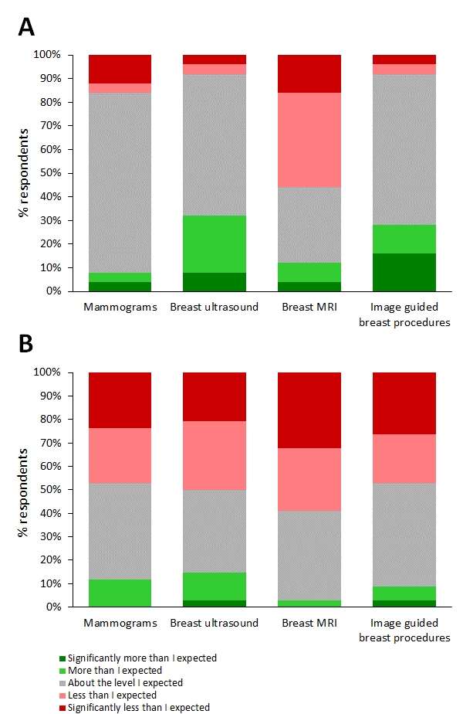

Figure 3 Trainees’ experiences of exposure to four key breast imaging modalities during their core breast rotations. (A) When core breast rotations were completed before the pandemic, n = 25; (B) When core breast rotations were completed during the pandemic, n = 34.
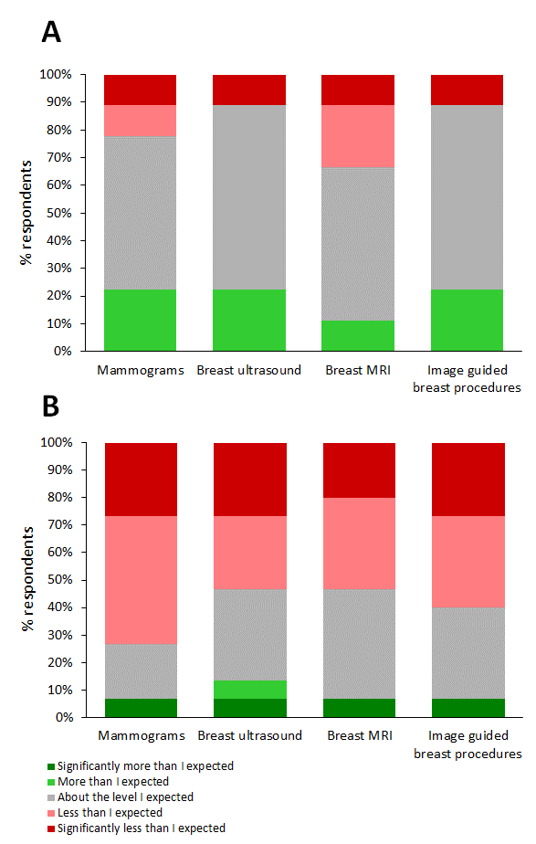

Figure 4 Higher trainees’ experiences of exposure to four key breast imaging modalities during their breast rotations. (A) When higher breast rotations were completed before the pandemic, n = 9; (B) When higher breast rotations were completed during the pandemic, n = 15.

Figure 5 Higher breast trainees’ workload during the pandemic compared to before it. n = 15.

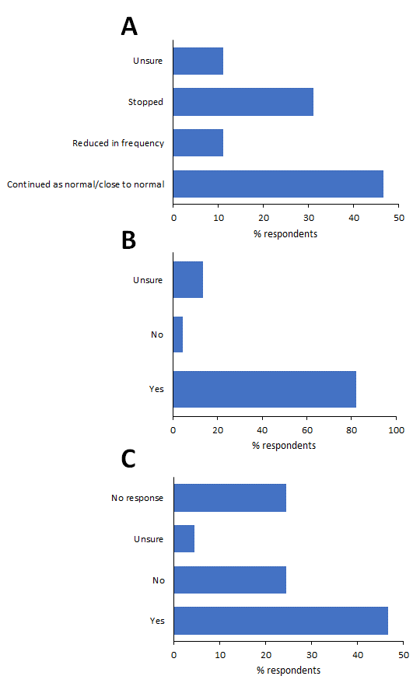
Figure 6 Access to multidisciplinary meetings and teaching for those completing a core or higher breast rotation during the pandemic (n = 45). A Did face to face breast multidisciplinary (MDT) meetings stop or reduce in frequency during this time? B Were there opportunities for remote access to join the breast multidisciplinary team (MDT) meeting? C Did your department explore any innovative means for breast radiology teaching e.g. via Microsoft Teams, Star Leaf, Zoom, or reviewing cases virtually?

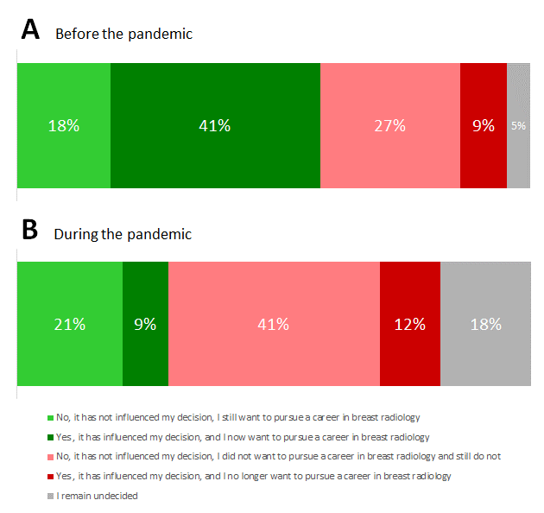

Figure 7 Impact of completing a core rotation before (A) or after (B) the pandemic on likelihood of pursuing higher breast radiology training.

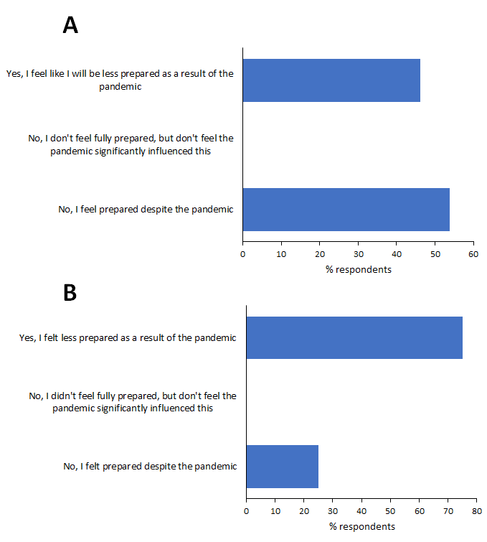

Figure 8 Impact of the pandemic on the perceived preparedness to become a consultant breast radiologist. (A) Higher breast radiology trainees, n = 13; (B) Consultant breast radiologists in their first year post CCT, n = 4.

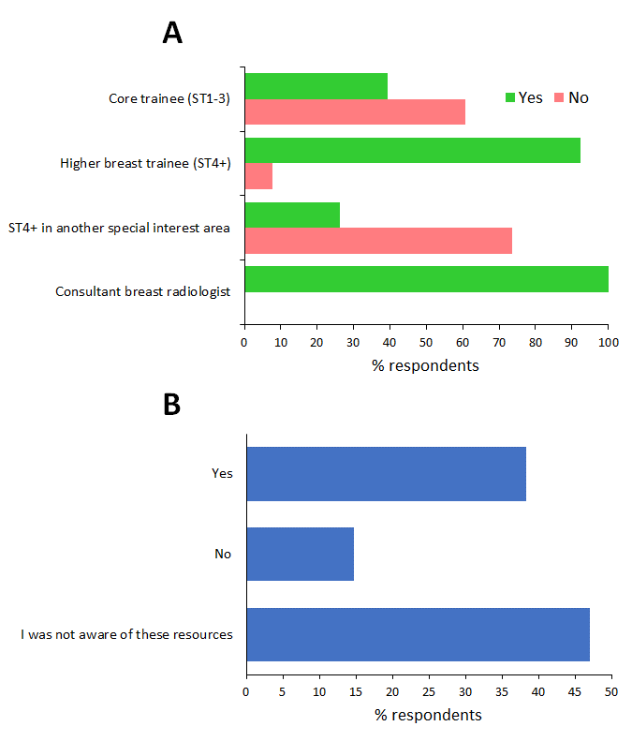

Figure 9 Awareness of the British Society of Breast Radiology (BSBR) prior to the invitation to complete the survey. (A) Shows the breakdown of those who had/had not heard of the BSBR, split according to training status. (B) Awareness of educational resources on the BSBR website for those who had heard of the BSBR, n = 34.
Tables
Defence Postgraduate Medical Deanery | 0
East Midlands | 5
East of England | 3
Kent, Surrey & Sussex | 1
London | 2
North East and North Cumbria | 15
North West | 11
Northern Ireland | 2
Scotland | 8
South West | 7
Thames Valley | 4
Wales | 3
Wessex | 1
West Midlands | 1
Yorkshire and the Humber | 6
 | 69

Table 1 Distribution of respondents by training region. Note that the London training schemes were grouped together as one, as were the Scottish training schemes.

Positive
Webinars (12)
Increased online teaching/educational material (12)
Online MDTs (6)
Audit/QIP opportunities increased (2)
More time (to be able to access resources) (3)
Virtual conferences (4)
Less commuting/travelling between sites (as a result of/allowing increased remote working/online resources) (2)
“More simulated biopsy experience, as less availability to practice on real patients” (1)

Negative
“No”/”None” (i.e. nothing positive to result from the pandemic) (9)
“Increased workload and had to home school children so no additional time to access educational resources” (1)
Mixed
"Remote courses definitely made them more accessible but it is not the same having all our teaching delivered virtually" (1)
“Unsure” (1)

Table 2 Responses to the question: “Looking back to the beginning of the pandemic and thinking about your breast radiology education, has there been anything positive to come out of the pandemic experience, e.g. on-demand webinars, increased time to access educational resources etc?” Common themes have been grouped. Verbatim responses are given in quotation marks. The number of comments per grouped theme/comment is given in parenthesis. Comments were received from 38 respondents; note that in some cases respondents made more than one comment and these have been counted separately.

Things that could have been done differently
More webinars (2)
“National higher breast trainee webinars would also have been of value.”
More online (live) teaching sessions/case-based reviews (3)
More online educational resources (e.g. bank of mammograms) (1)
More effort into (in-person) teaching to help get the most out of the placement (1)
Better access to home workstations/reporting facilities (e.g. for mammography) (1)
More/better opportunities for simulated biopsy practice (2)
Remote access to the MDM (1)
Dedicated time to allow for viewing of webinars and completion of eLfH modules. (1)
"Needed clinical exposure. Could have had core breast radiology catch-up programmes nationally?" (1)

Other comments
Missed out on breast MRI (2)
“If the normal rota was not disrupted it would have given more time for attending webinars and using other resources. Also stopping screening significantly reduced mammo reading numbers.” (1)
Not had a core breast rotation at ST1 or 2, though not necessarily as a result of the pandemic, so have missed an educational opportunity and any opportunity to experience breast radiology before making career choice (1)
“Not sure” (2)

No
“No” (13)
Specific comments: "I was as well supported as I could be"
“With such little time to prepare I think it would have been difficult”
“Happy with training during pandemic”
“Nothing could be done. The trainees were redeployed to the wards”
“None, I had a near normal core breast rotation.”
“Nothing. It was great.”

Table 3 Responses to the question: “Again, looking back to the beginning of the pandemic and thinking about your breast radiology education, what do you think could have been done differently to support your breast education?” Common themes have been grouped. Verbatim responses are given in quotation marks. The number of comments per grouped theme/comment is given in parenthesis. Comments were received from 28 respondents; note that in some cases respondents made more than one comment and these have been counted separately.

Appendix 1
- What is your current grade?
- Which Deanery did you work in during the COVID-19 pandemic?
- How many trainees typically work in your local breast department in each rotation?
- During the COVID-19 pandemic were you re-deployed to other departments in the hospital at any point?
- Overall, what impact has the COVID-19 pandemic had on your breast training (whether core or higher)?
- Did you complete a core breast rotation at any point before the beginning of the COVID-19 pandemic?
- Thinking about your experience before the pandemic, how did your level of exposure to different imaging modalities in breast radiology compare to your expectations?
- Again, thinking about your core breast training before the pandemic, did your experience during the rotation impact your future career choice?
- Did you complete a core breast rotation at any point during the COVID-19 pandemic?
- Thinking about your experience during the pandemic, how did your level of exposure to different imaging modalities in breast radiology compare to your expectations?
- Again, thinking about your core breast training during the pandemic, has your experience during this period impacted your future career choice?
- Were you in higher breast training at any point before the beginning of the COVID-19 pandemic?
- Thinking about your overall level of exposure to different breast imaging modalities during your higher breast rotations prior to the pandemic, how do you feel about your level of exposure to the following?
- Were you in higher breast training at any point during the COVID-19 pandemic?
- For all respondents who were on a higher breast rotation during to the pandemic, how do you feel about your level of exposure to the following breast imaging modalities?
- Again, thinking about your higher breast training during the pandemic, how did you feel your workload in the breast unit was affected compared to before the pandemic?
- For all core/higher respondents who were on a breast rotation during the pandemic, did face to face breast multidisciplinary (MDT) meetings stop or reduce in frequency during this time?
- Were there opportunities for remote access to join the breast multidisciplinary team (MDT) meeting?
- If you were on a core or higher breast rotation during the pandemic, did your department explore any innovative means for breast radiology teaching e.g. via Microsoft Teams, Star Leaf, Zoom, or reviewing cases virtually? Please give as much detail as possible.
- Looking back to the beginning of the pandemic and thinking about your breast radiology education, has there been anything positive to come out of the pandemic experience, e.g. on-demand webinars, increased time to access educational resources etc?
- Again, looking back to the beginning of the pandemic and thinking about your breast radiology education, what do you think could have been done differently to support your breast education?
- Before you received the invitation to carry out this survey, were you aware of the British Society of Breast Radiology (BSBR)?
- Did you find the links to any educational resources or learning modules available on the BSBR website e.g. link to eLFH during the pandemic?
- As a future or current consultant breast radiologist, overall, do you feel the COVID-19 pandemic has affected your preparedness for becoming a consultant?
- If you would like to be entered into a prize draw for one of three prizes of Amazon vouchers ( £100, £50 or £25), please enter your email address below. Note: this will only be used to randomly select the winners and to contact you if you win. It will not be used for any other purpose.

